Assignment 5

Que 1. write a query that will give you all orders for more
than Rs. 1000.
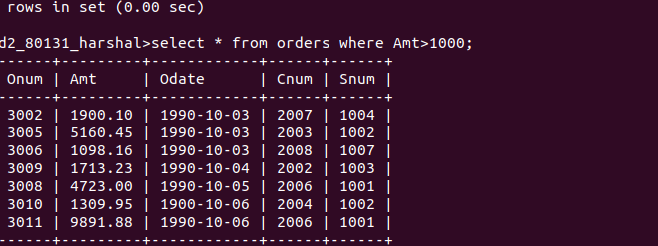

Que 2. write a query that will give you the names and cities of all salespeopl in london with a commission above 0.10.

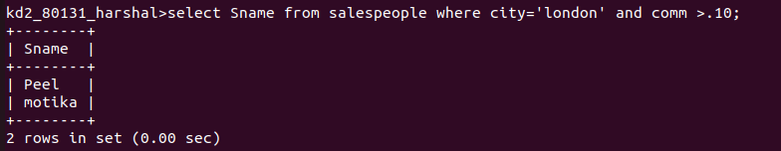

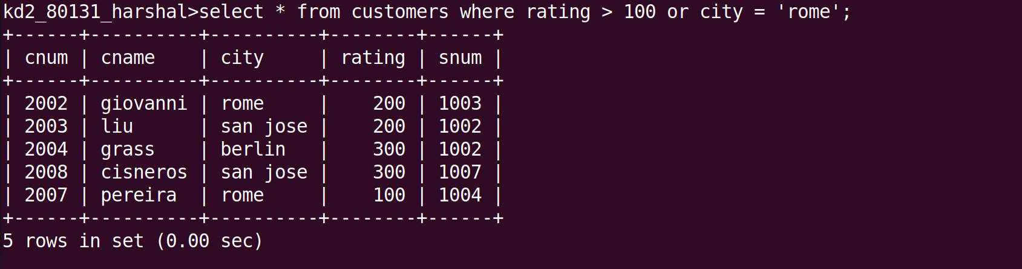
Que 3. writ a query on the customers table whose output will exclude all customer with a rating <= 100, unles they are located in Rome.

Que 4. what will be the output from the following query ?
Select * from orders where ( amt < 1000 OR NOT (odate = ‘1990-10-03’ AND cnum > 2003 ));

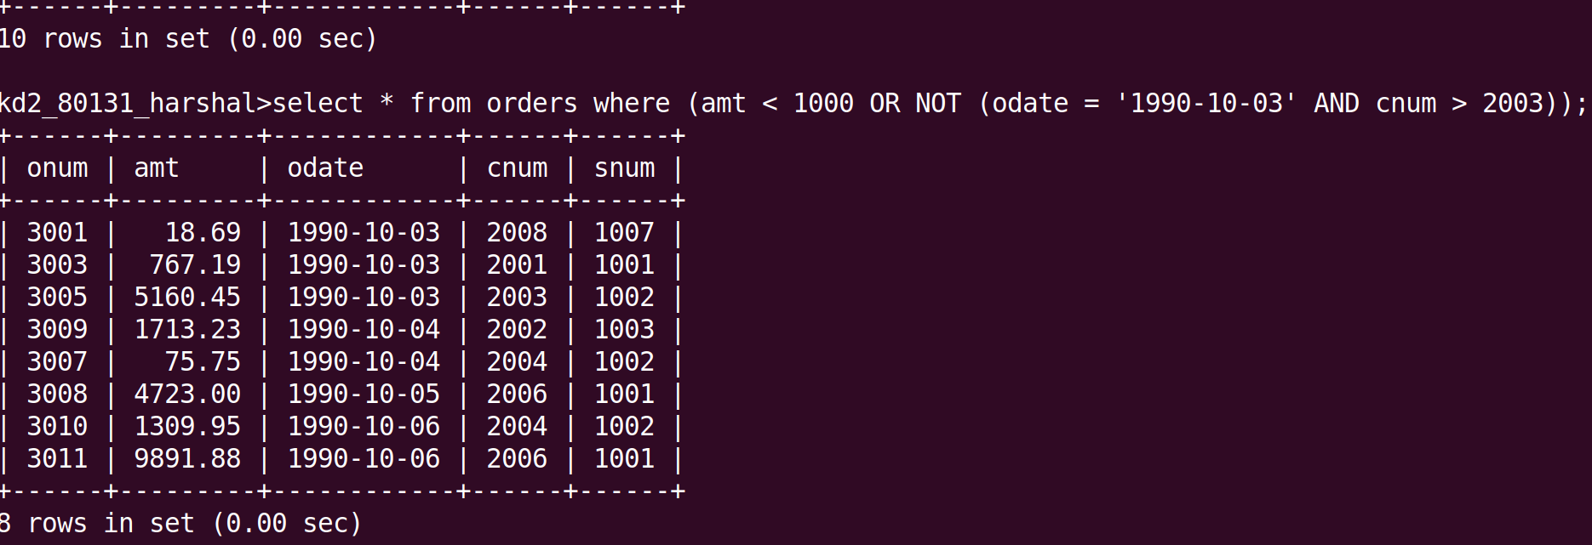
Que 5. what will be the output from the following query ?
Select * from orders where NOT ((odate = ‘1990-10-03’ OR snum > 1006) AND amt >= 1500);
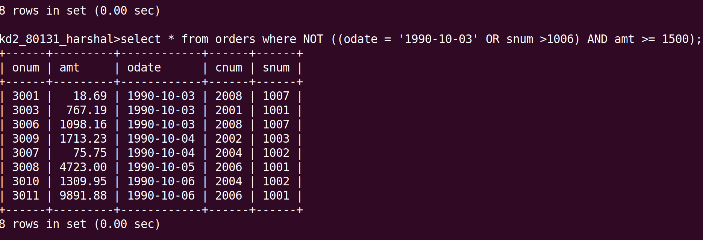

Que 6. What is a simpler way to write this query ?
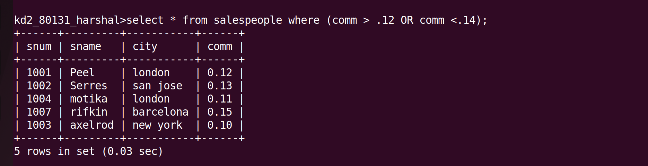
Select snum, sname, city, comm from salespeople where (comm > 0.12 OR comm <0.14 );

